Name :- Abhishek pundir

Student id:- 20711162

U. roll no. :- 2001008

Course :- MCA

Section :- C

End term practical

1.Write a java program for Client Server communication using UDP Datagram Socket Programming

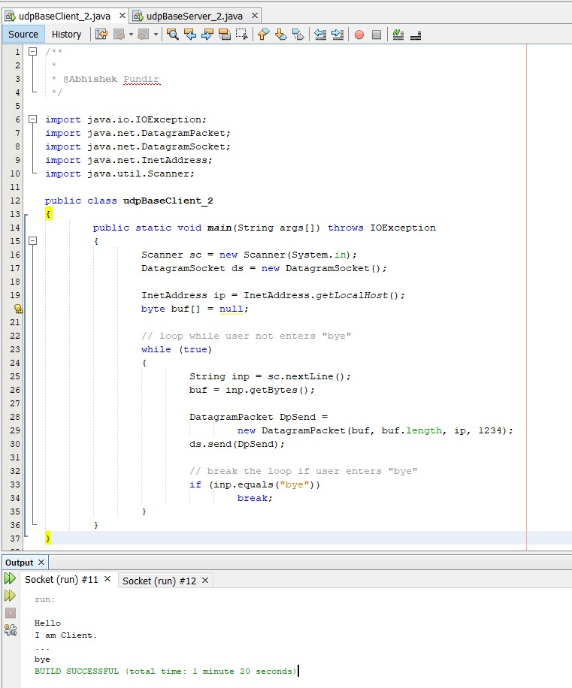

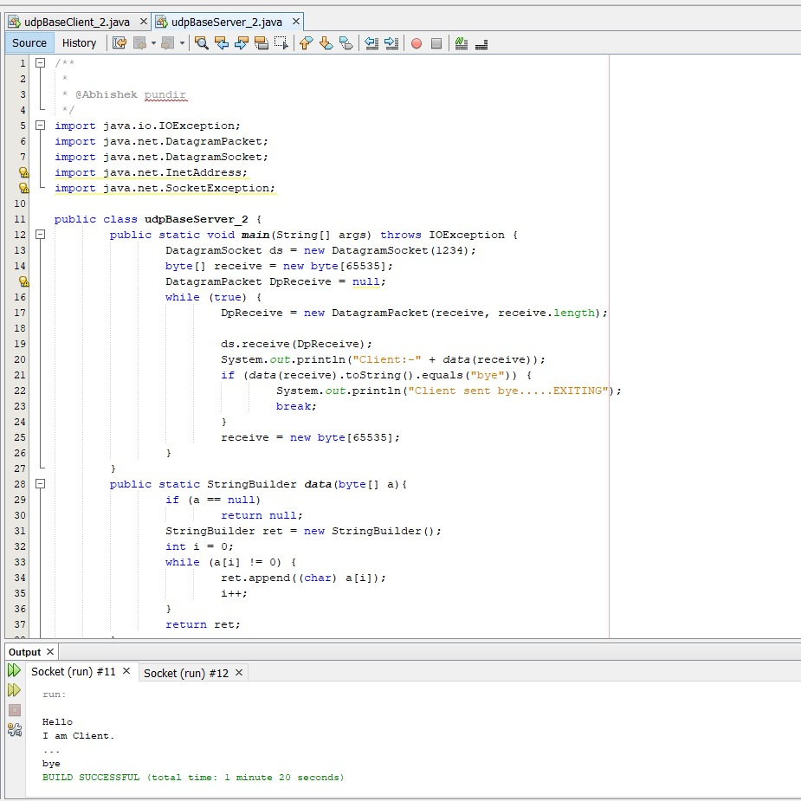

2.Write a program to demonstrate status of key on Applet window such as KeyPressed, KeyReleased, KeyUp, KeyDown

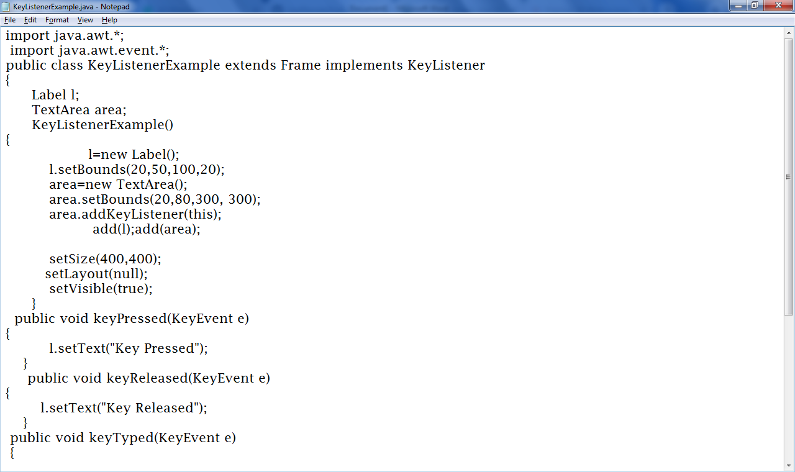

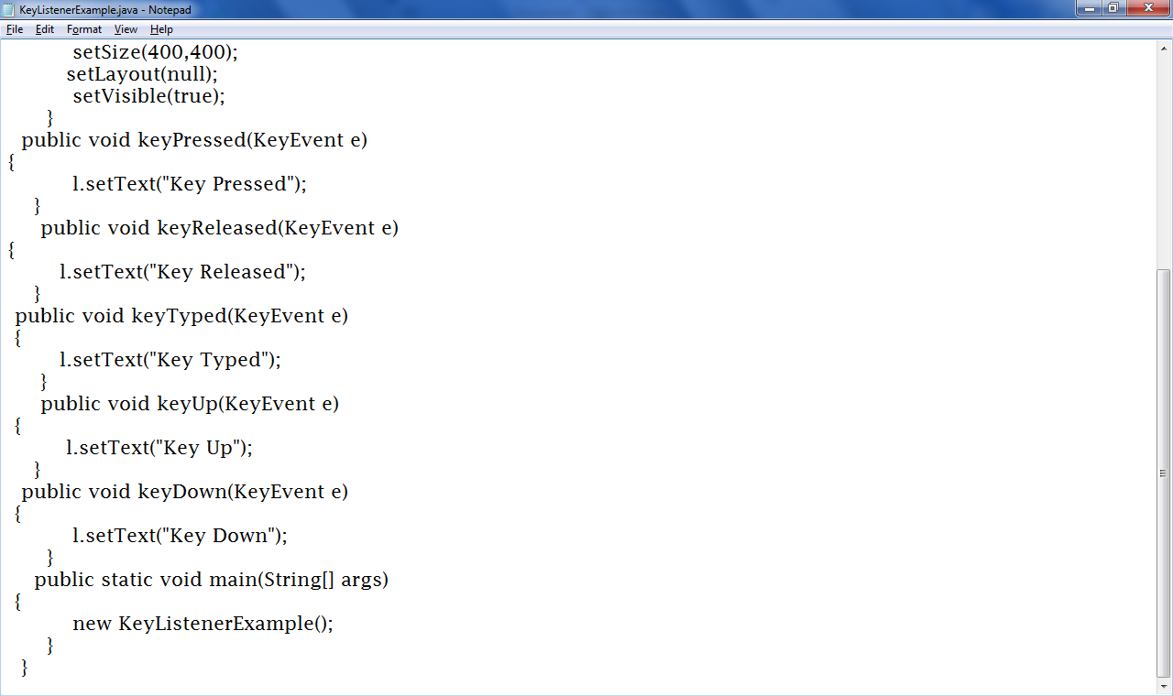

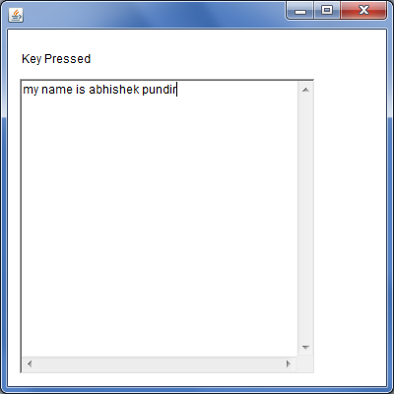

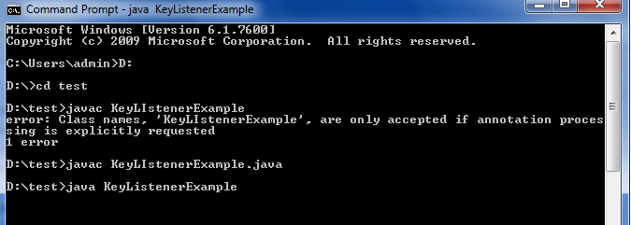

3.Write a java program to create a file with your name, save it in the desktop, write some data on the file and then read and print that data into the console.

